**SQL Capstone Project**

**Project Title: Online Chocolate Shop Management System**

Project Overview:

Design and implement a database system for an online chocolate shop. The system should handle various aspects of managing the shop, including inventory management, customers, orders and user authentication

Skills Demonstrated:

**Beginner:**

* Creating tables and defining relationships
* Basic CRUD(Create, Read, Update, Delete) operations

USE:

USE chocolate;

DROP:

–Dropped tables due to Foreign Key related errors/order of operations

DROP TABLE chocolates;

DROP TABLE orders;

DROP TABLE customers, contact_info; –Foreign key work around

CREATE:

create table chocolates(

chocolate_id int not null auto_increment,

chocolate_name varchar(255),

price_per_ounce_dollars float(5,2),

primary key (chocolate_id)

);

create table customers(

customer_id int not null auto_increment,

first_name varchar(255),

last_name varchar(255),

contact_info_id int,

primary key (customer_id)

);

create table orders(

order_id int not null auto_increment,

order_timestamp date,

customer_id int,

chocolate_id int,

order_amount_ounces float(5,2),

order_price float(5,2),

primary key (order_id)

);

create table contact_info(

contact_info_id int not null auto_increment,

customer_id int,

address_number int,

street varchar(255),

city varchar(255),

zip int,

phone_number int,

email varchar(255),

primary key (contact_info_id)

);

-INSERT:

INSERT INTO chocolates (chocolate_name, price_per_ounce_dollars) VALUES

('Dark Chocolate', 2.50),

('Milk Chocolate', 2.00),

('White Chocolate', 2.75),

('Semisweet Chocolate', 2.75),

('Bittersweet Chocolate', 2.85),

('Unsweetened Chocolate', 2.50),

('Cocoa Powder', 1.95),

('German Chocolate', 3.20),

('Couverture Chocolate', 3.50),

('Ruby Chocolate', 3.75);

SELECT * FROM chocolates;

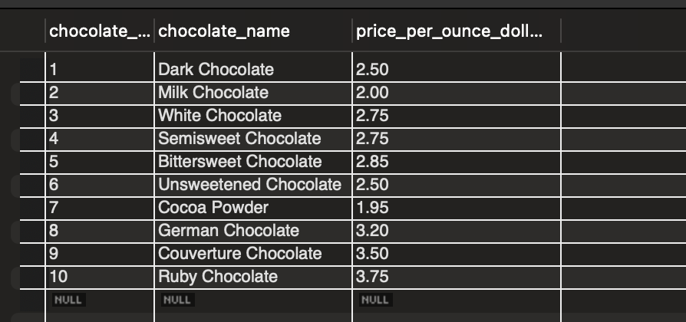

INSERT INTO customers (first_name, last_name, contact_info_id) VALUES

('John', 'Doe', 1),

('Jane', 'Smith', 2),

('Michael', 'Johnson', 3),

('Alice', 'Johnson', 4),

('Bob', 'Smith', 5),

('Emily', 'Davis', 6),

('James', 'Wilson', 7),

('Sophia', 'Martinez', 8),

('Daniel', 'Anderson', 9),

('Olivia', 'Taylor', 10);

SELECT * from customers;

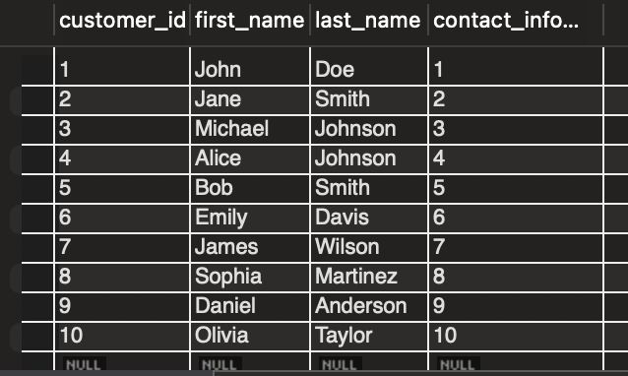

INSERT INTO orders (order_timestamp, customer_id, chocolate_id, order_amount_ounces, order_price) VALUES

('2024-05-09', 1, 1, 10.0, 25.00),

('2024-05-09', 2, 2, 8.0, 16.00),

('2024-05-09', 3, 3, 6.0, 16.50),

('2024-05-10', 2, 1, 5.0, 12.50),

('2024-05-10', 3, 3, 4.0, 11.00),

('2024-05-11', 1, 5, 3.0, 9.60),

('2024-05-12', 4, 2, 7.0, 19.95),

('2024-05-12', 5, 6, 2.5, 8.75),

('2024-05-13', 6, 4, 6.0, 13.80),

('2024-05-14', 7, 7, 3.5, 13.13);

SELECT * from customers;

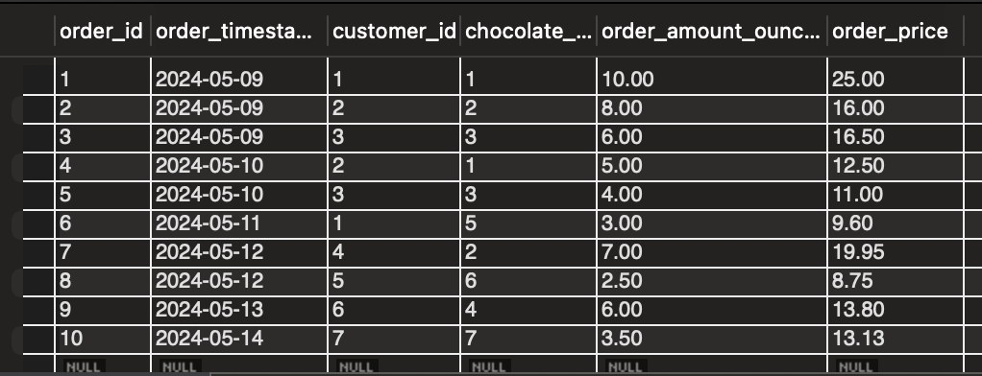

INSERT INTO contact_info (customer_id, address_number, street, city, zip, phone_number, email) VALUES

(1, 123, 'Main St', 'Anytown', 12345, 1551234567, 'john@example.com'),

(2, 456, 'Broadway', 'Othertown', 54321, 1559876543, 'jane@example.com'),

(3, 789, 'Oak St', 'Somewhere', 98765, 1555555555, 'michael@example.com'),

(4, 321, 'Maple Ave', 'Somewhere', 54321, 1553334444, 'bob@example.com'),

(5, 654, 'Elm St', 'Othertown', 98765, 1554445555, 'emily@example.com'),

(6, 987, 'Pine Rd', 'Anytown', 12345, 1555556666, 'james@example.com'),

(7, 123, 'Oak St', 'Somewhere', 54321, 1556667777, 'sophia@example.com'),

(8, 456, 'Cedar Ln', 'Anytown', 12345, 1557778888, 'daniel@example.com'),

(9, 789, 'Birch Dr', 'Othertown', 98765, 1558889999, 'olivia@example.com'),

(10, 987, 'Spruce Ct', 'Somewhere', 54321, 1559990000, 'customer@example.com');

SELECT * FROM contact_info;

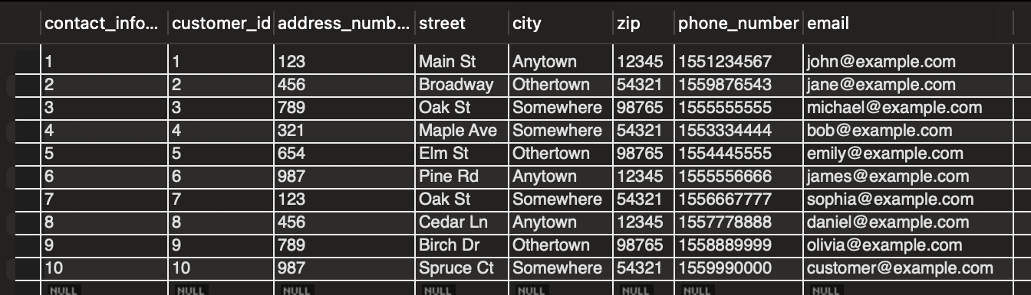

* Simple queries using SELECT, WHERE, and ORDER BY clauses

-- Retrieve all chocolates with a price per ounce greater than $3.00, ordered by chocolate name:

SELECT chocolate_name, price_per_ounce_dollars

FROM chocolates

WHERE price_per_ounce_dollars > 3.00

ORDER BY chocolate_name;

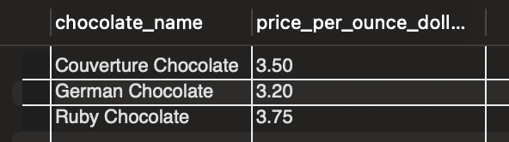

-- Retrieve all customers who have placed an order, along with their contact information, ordered by last name:

SELECT c.first_name, c.last_name, ci.street, ci.city, ci.phone_number, ci.email

FROM customers c

JOIN contact_info ci ON c.contact_info_id = ci.contact_info_id

WHERE c.customer_id IN (SELECT DISTINCT customer_id FROM orders)

ORDER BY c.last_name;

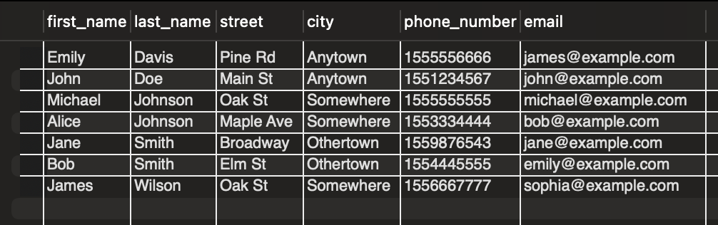

-- Retrieve the top 5 customers with the highest total order amounts,

-- along with the total order amount for each customer, ordered by total order amount (descending):

SELECT c.first_name, c.last_name, SUM(o.order_price) AS total_order_amount

FROM customers c

JOIN orders o ON c.customer_id = o.customer_id

GROUP BY c.customer_id

ORDER BY total_order_amount DESC

LIMIT 5;

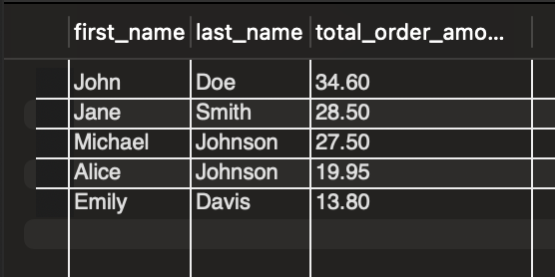

-- Retrieve the orders placed on May 10, 2024, along with the customer's first name,

-- last name, and order amount, ordered by order amount (descending):

SELECT c.first_name, c.last_name, o.order_amount_ounces, o.order_price

FROM customers c

JOIN orders o ON c.customer_id = o.customer_id

WHERE o.order_timestamp = '2024-05-10'

ORDER BY o.order_amount_ounces DESC;

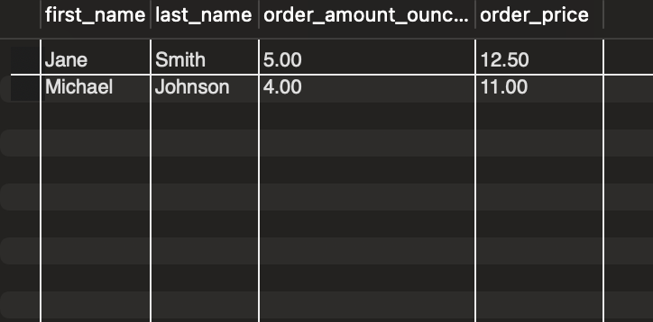

-- Retrieve the contact information for customers who have placed orders for cocoa powder, ordered by city:

SELECT ci.*

FROM contact_info ci

JOIN customers c ON ci.customer_id = c.customer_id

JOIN orders o ON c.customer_id = o.customer_id

JOIN chocolates ch ON o.chocolate_id = ch.chocolate_id

WHERE ch.chocolate_name = 'Cocoa Powder'

ORDER BY ci.city;

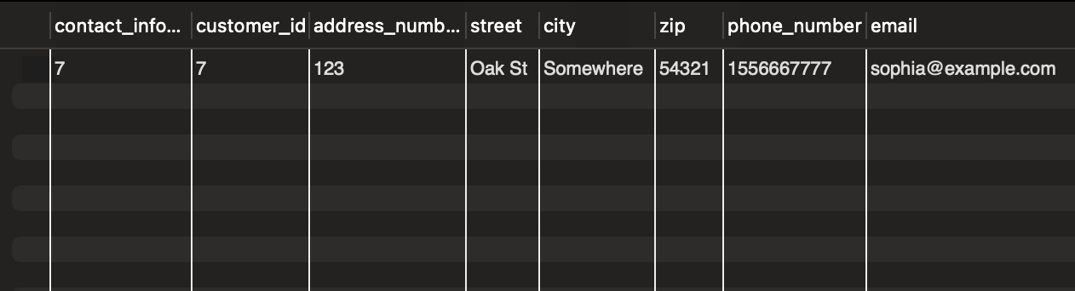

**Intermediate:**

* Implementing constraints and indexes for data integrity and performance optimization

Foreign Keys:

alter table customers add foreign key (contact_info_id) references contact_info(contact_info_id);

alter table contact_info add foreign key (customer_id) references customers(customer_id);

* Utilizing JOIN operations for querying data from multiple tables

-- Retrieve the details of all orders, including the customer's first and last name:

SELECT orders.order_id, orders.order_timestamp, customers.first_name, customers.last_name

FROM orders

JOIN customers ON orders.customer_id = customers.customer_id;

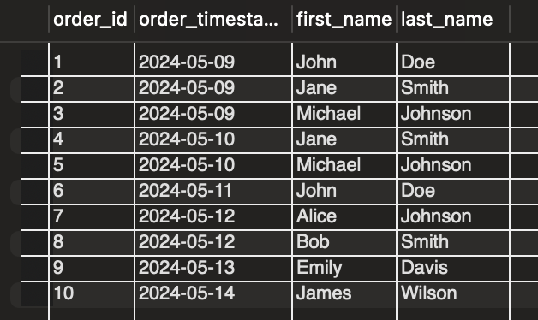

-- Retrieve the total order amount and customer's email for each order placed on a specific date:

SELECT orders.order_id, SUM(orders.order_price) AS total_order_amount, contact_info.email

FROM orders

JOIN customers ON orders.customer_id = customers.customer_id

JOIN contact_info ON customers.contact_info_id = contact_info.contact_info_id

WHERE orders.order_timestamp = '2024-05-10'

GROUP BY orders.order_id;

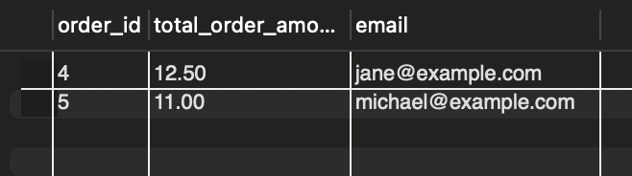

-- Retrieve the details of customers who ordered a specific chocolate, along with their address information:

SELECT customers.first_name, customers.last_name, contact_info.address_number, contact_info.street, contact_info.city, contact_info.zip

FROM customers

JOIN orders ON customers.customer_id = orders.customer_id

JOIN chocolates ON orders.chocolate_id = chocolates.chocolate_id

JOIN contact_info ON customers.contact_info_id = contact_info.contact_info_id

WHERE chocolates.chocolate_name = 'Semisweet Chocolate';

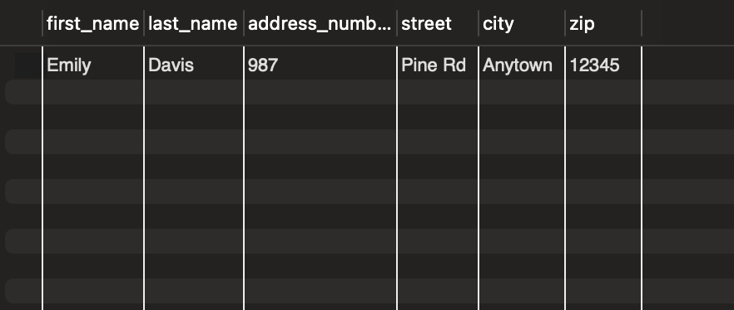

-- Retrieve the order details for a specific customer, including the chocolate name and price per ounce:

SELECT orders.order_id, orders.order_timestamp, chocolates.chocolate_name, chocolates.price_per_ounce_dollars

FROM orders

JOIN chocolates ON orders.chocolate_id = chocolates.chocolate_id

WHERE orders.customer_id = 1;

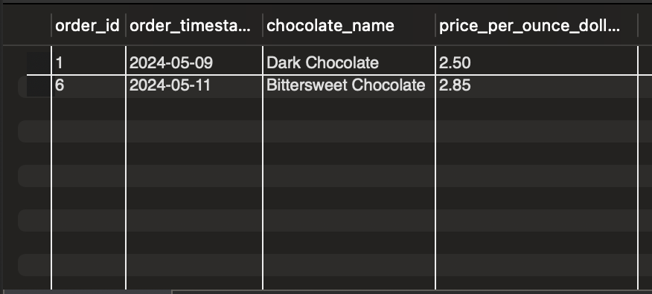

-- Retrieve the total revenue generated by each chocolate type:

SELECT chocolates.chocolate_name, SUM(orders.order_price) AS total_revenue

FROM orders

JOIN chocolates ON orders.chocolate_id = chocolates.chocolate_id

GROUP BY chocolates.chocolate_name;

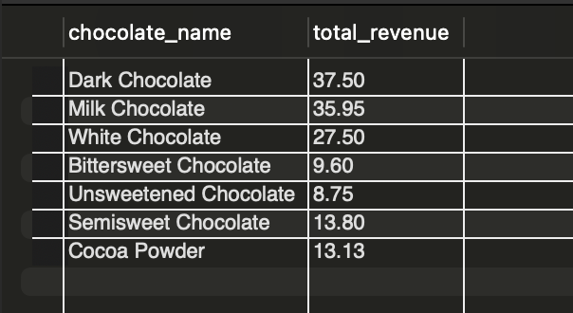

* Aggregating data using GROUP BY and aggregate functions

-- Calculate the total number of orders placed by each customer:

SELECT customers.customer_id, customers.first_name, customers.last_name, COUNT(orders.order_id) AS total_orders

FROM customers

LEFT JOIN orders ON customers.customer_id = orders.customer_id

GROUP BY customers.customer_id;

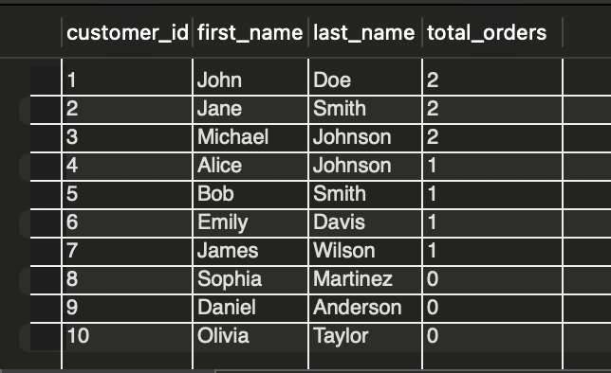

-- Find the average order price for each chocolate:

SELECT chocolates.chocolate_name, AVG(orders.order_price) AS average_order_price

FROM chocolates

LEFT JOIN orders ON chocolates.chocolate_id = orders.chocolate_id

GROUP BY chocolates.chocolate_name;

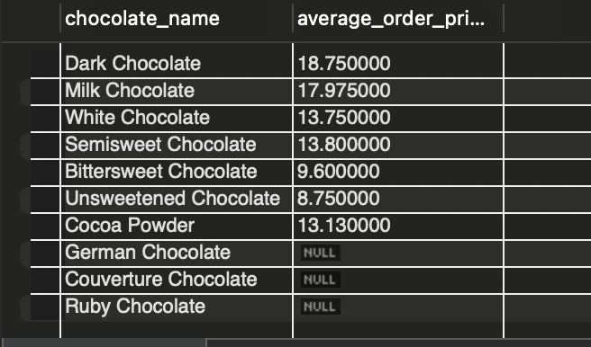

-- Determine the maximum order amount (in ounces) placed by each customer:

SELECT customers.customer_id, customers.first_name, customers.last_name, MAX(orders.order_amount_ounces) AS max_order_amount_ounces

FROM customers

LEFT JOIN orders ON customers.customer_id = orders.customer_id

GROUP BY customers.customer_id;

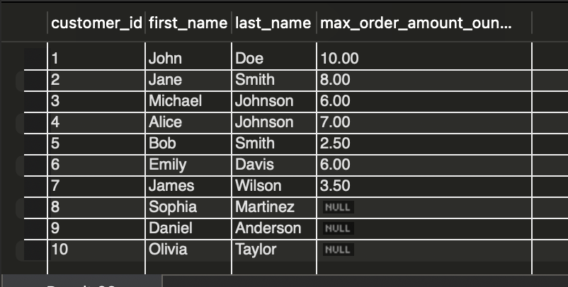

-- Calculate the total revenue generated for each city:

SELECT contact_info.city, SUM(orders.order_price) AS total_revenue

FROM contact_info

LEFT JOIN customers ON contact_info.contact_info_id = customers.contact_info_id

LEFT JOIN orders ON customers.customer_id = orders.customer_id

GROUP BY contact_info.city;

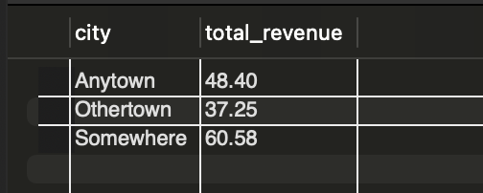

-- Find the minimum and maximum prices per ounce for each chocolate:

SELECT chocolates.chocolate_name, MIN(chocolates.price_per_ounce_dollars) AS min_price_per_ounce, MAX(chocolates.price_per_ounce_dollars) AS max_price_per_ounce

FROM chocolates

GROUP BY chocolates.chocolate_name;

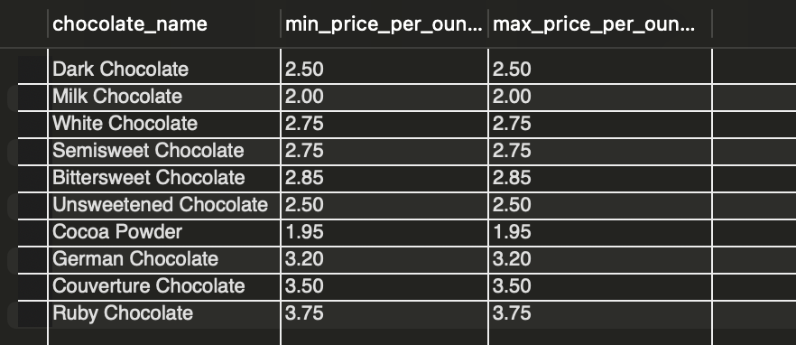

* Implementing views and stored procedures for modularizing queries and operations

-- Customer Orders View:

CREATE VIEW customer_orders AS

SELECT c.first_name, c.last_name, ci.email, o.order_id, o.order_timestamp, ch.chocolate_name, o.order_amount_ounces, o.order_price

FROM customers c

JOIN orders o ON c.customer_id = o.customer_id

JOIN chocolates ch ON o.chocolate_id = ch.chocolate_id

JOIN contact_info ci ON c.contact_info_id = ci.contact_info_id;

SELECT * FROM chocolate.customer_orders;

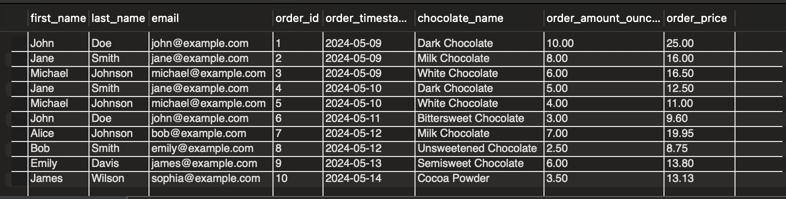

-- Total Revenue by Chocolate View:

CREATE VIEW total_revenue_by_chocolate AS

SELECT ch.chocolate_name, SUM(o.order_price) AS total_revenue

FROM chocolates ch

JOIN orders o ON ch.chocolate_id = o.chocolate_id

GROUP BY ch.chocolate_name;

SELECT * FROM chocolate.total_revenue_by_chocolate;

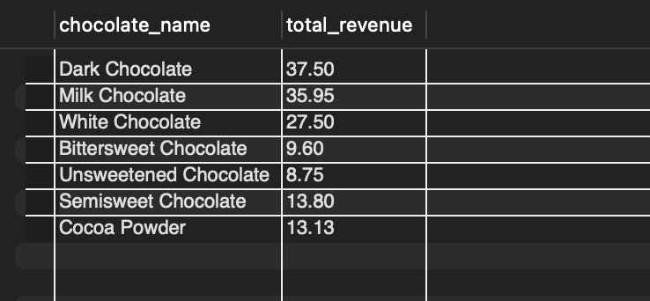

-- High-Value Customers View:

CREATE VIEW high_value_customers AS

SELECT c.customer_id, c.first_name, c.last_name, ci.email, SUM(o.order_price) AS total_order_amount

FROM customers c

JOIN orders o ON c.customer_id = o.customer_id

JOIN contact_info ci ON c.contact_info_id = ci.contact_info_id

GROUP BY c.customer_id

ORDER BY total_order_amount DESC;

SELECT * FROM chocolate.high_value_customers;

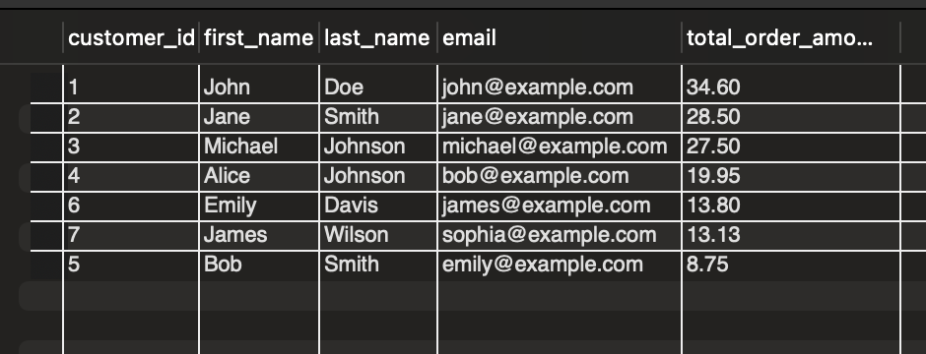

-- Top-Selling Chocolates View:

CREATE VIEW top_selling_chocolates AS

SELECT ch.chocolate_name, SUM(o.order_amount_ounces) AS total_quantity_sold, SUM(o.order_price) AS total_revenue

FROM chocolates ch

JOIN orders o ON ch.chocolate_id = o.chocolate_id

GROUP BY ch.chocolate_name

ORDER BY total_quantity_sold DESC;

SELECT * FROM chocolate.top_selling_chocolates;

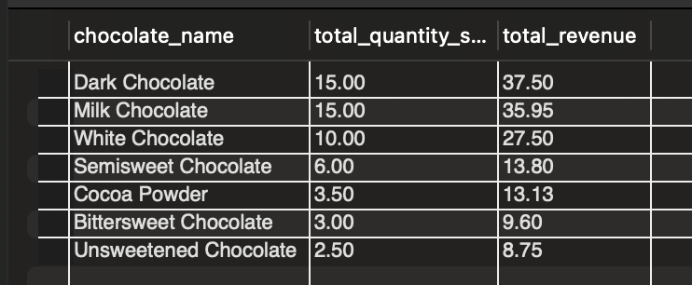

-- Monthly Revenue Trend View:

CREATE VIEW monthly_revenue_trend AS

SELECT YEAR(o.order_timestamp) AS year, MONTH(o.order_timestamp) AS month, SUM(o.order_price) AS total_revenue

FROM orders o

GROUP BY YEAR(o.order_timestamp), MONTH(o.order_timestamp)

ORDER BY year, month;

SELECT * FROM chocolate.monthly_revenue_trend;

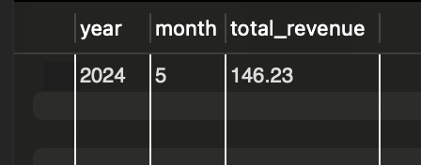

-- Customer Location View:

CREATE VIEW customer_location AS

SELECT ci.city, ci.zip, COUNT(*) AS customer_count

FROM contact_info ci

JOIN customers c ON ci.contact_info_id = c.contact_info_id

GROUP BY ci.city, ci.zip;

SELECT * FROM chocolate.customer_location;

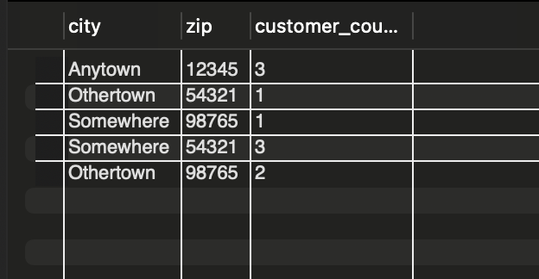

**Advanced:**

* Handling transactions for maintaining data consistency and integrity

-- Add the inventory_quantity column to the chocolates table

ALTER TABLE chocolates ADD COLUMN inventory_quantity INT DEFAULT 0;

-- Begin a new transaction

START TRANSACTION;

-- Perform database operations within the transaction

INSERT INTO orders (customer_id, chocolate_id, order_amount_ounces, order_price) VALUES (1, 3, 2.5, 15.00);

UPDATE chocolates SET inventory_quantity = inventory_quantity - 2.5 WHERE chocolate_id = 3;

-- Commit the transaction to make its changes permanent

COMMIT;

-- Begin another transaction

START TRANSACTION;

-- Perform more database operations within the transaction

INSERT INTO orders (customer_id, chocolate_id, order_amount_ounces, order_price) VALUES (2, 1, 3.0, 20.00);

UPDATE chocolates SET inventory_quantity = inventory_quantity - 3.0 WHERE chocolate_id = 1;

-- Set a savepoint within the transaction

SAVEPOINT after_first_order;

-- Perform additional operations

INSERT INTO orders (customer_id, chocolate_id, order_amount_ounces, order_price) VALUES (2, 4, 1.5, 12.00);

UPDATE chocolates SET inventory_quantity = inventory_quantity - 1.5 WHERE chocolate_id = 4;

-- Rollback to the savepoint to undo changes made after it

ROLLBACK TO SAVEPOINT after_first_order;

-- Commit the transaction to make its changes permanent

COMMIT;

SELECT * FROM chocolates;

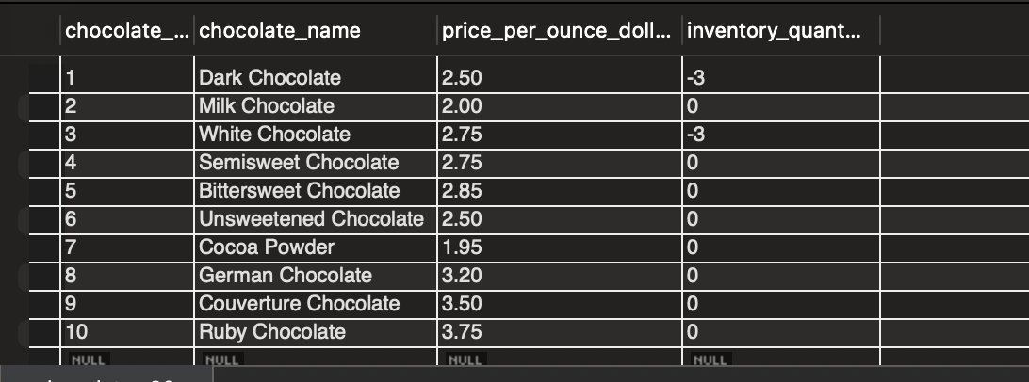

* Implementing complex queries involving subqueries, common table expressions, and window functions

-- Find customers who have placed orders for chocolates with a price higher than the average price,

-- along with their rank based on total order amount

WITH customer_order_totals AS (

SELECT customer_id, SUM(order_price) AS total_amount

FROM orders

GROUP BY customer_id

)

SELECT customer_id, total_amount,

RANK() OVER (ORDER BY total_amount DESC) AS total_order_rank

FROM customer_order_totals

WHERE EXISTS (

SELECT 1

FROM orders

WHERE customer_id = customer_order_totals.customer_id

AND order_price > (SELECT AVG(order_price) FROM orders)

);

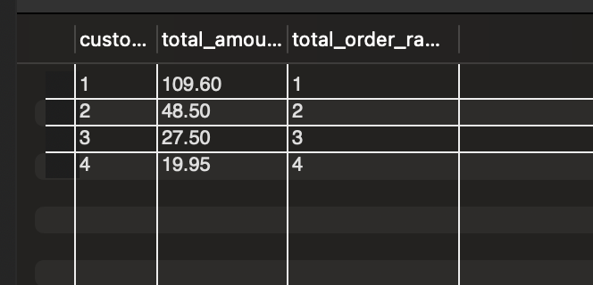

* Performance tuning using query optimization techniques like query plans and indexes

-- Create a composite index on (order_timestamp, customer_id) columns in the orders table

CREATE INDEX idx_order_timestamp_customer_id ON orders(order_timestamp, customer_id);

-- Create a composite index on (customer_id, chocolate_id) columns in the orders table

CREATE INDEX idx_customer_id_chocolate_id ON orders(customer_id, chocolate_id);

* Implementing security measures such as roles and permissions to restrict access to sensitive data

– Error Code: 1410. You are not allowed to create a user with GRANT

CREATE USER 'username'@'localhost' IDENTIFIED BY 'password';

-- Grant privileges to the user account

GRANT SELECT, INSERT, UPDATE ON chocolate.* TO 'username'@'localhost';

GRANT role TO 'username'@'localhost';

SELECT * FROM mysql.role_edges;

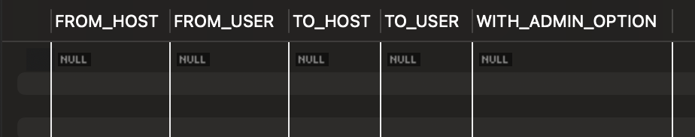

SHOW GRANTS;

GRANT ALL PRIVILEGES ON *.* TO 'root'@'localhost' WITH GRANT OPTION;

– no dice

GRANT GRANT OPTION ON *.* TO 'root'@'localhost' WITH GRANT OPTION;

– no dice

Project Components:

1. **Database Design:**
   1. Design the database schema, including tables for chocolate, customers, and orders
   2. Define relationships between tables
   3. Implement constraints for data integrity
2. **Data Population:**
   1. Populate the database with sample data for chocolate, customers, and orders
   2. Ensure data consistency and referential integrity
3. **Basic Operations:**
   1. Implement CRUD operations for managing chocolate, customers, and orders
   2. Allow users to add, update and delete records from the database
4. **Intermediate Queries:**
   1. Create queries to retrieve information such as:
      1. Top-selling chocolate
      2. Customers with the highest order amounts
      3. Total revenue generated over a specific period
      4. Chocolate with low inventory levels
   2. Utilize JOIN operations to fetch data from multiple related tables
5. **Advanced Features:**
   1. Implement transactions to ensure atomicity and consistency during order processing
   2. Develop complex queries to answer specific business questions(e.g., identifying patterns in customer behavior)
   3. Optimize query performance by analyzing query execution plans and indexing strategies
   4. Implement role-based access control to restrict access to sensitive data and operations
6. **Documentation and Presentation:**
   1. Document the database schema, including tables, relationships, and constraints
   2. Provide explanations for the implemented features and query optimization techniques